|  |
| --- |
| **UNIT 2: TRANH CÓ ĐỒ VẬT & TRANH PHONG CẢNH** |

**I. PHÂN TÍCH TRANH CÓ ĐỒ VẬT:**

1. Tranh có đồ vật, tất nhiên, sẽ lấy đồ vật làm trung tâm. Lúc này trong tranh sẽ không có người. Do đó, các câu mô tả đúng luôn là những câu chỉ trạng thái đồ vật.

2. Những câu chỉ trạng thái đồ vật thì dùng thì hiện tại đơn dạng chủ động “is/are + giới từ”, dạng bị động “is/are + V3/V-ed” hoặc bị động của thì hiện tại hoàn thành “has/have been + V3/V-ed”.

3. Tranh không có người nên những câu dạng bị động của thì hiện tại tiếp diễn “is/are + being + V3/V-ed” mô tả hành động của người luôn là phương án sai.

4. Tranh không có người và lấy đồ vật làm trung tâm nên những câu mô tả có chủ ngữ chỉ người: a man/woman; he/she/they; some/many + men/women/people; danh từ chỉ người đều là phương án sai.

5. Một số câu chỉ trạng thái cũng có thể dùng dạng chủ động của thì hiện tại tiếp diễn “is/are + V-ing”. Lúc này động từ diễn tả trạng thái chứ không phải hành động. Do đó, những câu như vậy vẫn có thể là phương án đúng.

6. Ví dụ & phân tích:

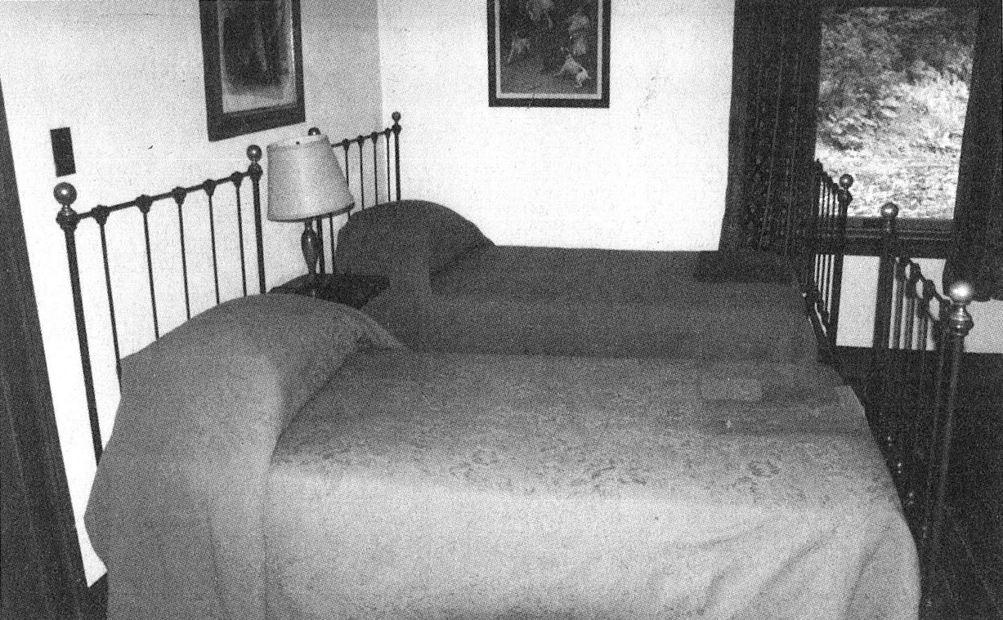

• There are two pictures hanging on the wall. [Có 2 bức tranh treo trên tường.]

• There is a lamp between the beds.

[Có một cái đèn chụp ở giữa những chiếc giường.]

• The curtains have been pulled to both sides of the window.

[Những chiếc rèm đã được kéo sang 2 bên cửa sổ.]

**II. PHÂN TÍCH TRANH PHONG CẢNH:**

1. Tranh phong cảnh có thể có hình ảnh về cây cối, nhà cửa, đường phố v.v… Lúc này tranh sẽ không có người hoặc không đặt con người làm trọng tâm.

2. Những câu chỉ trạng thái của cây cối, nhà cửa, xe cộ v.v…thì dùng thì hiện tại đơn dạng chủ động “is/are + giới từ”, dạng bị động “is/are + V3/V-ed” hoặc bị động của thì hiện tại hoàn thành “has/have been + V3/V-ed”.

3. Tương tự như tranh có đồ vật, tranh phong cảnh cũng sẽ không có người. Do đó những câu dùng thì dạng bị động của thì hiện tại tiếp diễn “is/are + being + V3/V-ed” mô tả hành động của người luôn là phương án sai.

4. Tranh không có người nên những câu mô tả có chủ ngữ chỉ người: a man/woman; he/she/they; some/many + men/women/people; danh từ chỉ người đều là phương án sai.

5. Một số câu chỉ trạng thái cũng có thể dùng dạng chủ động của thì hiện tại tiếp diễn “is/are + V-ing”. Lúc này động từ diễn tả trạng thái chứ không phải hành động. Do đó, những câu như vậy vẫn có thể là phương án đúng.

6. Ví dụ & phân tích:

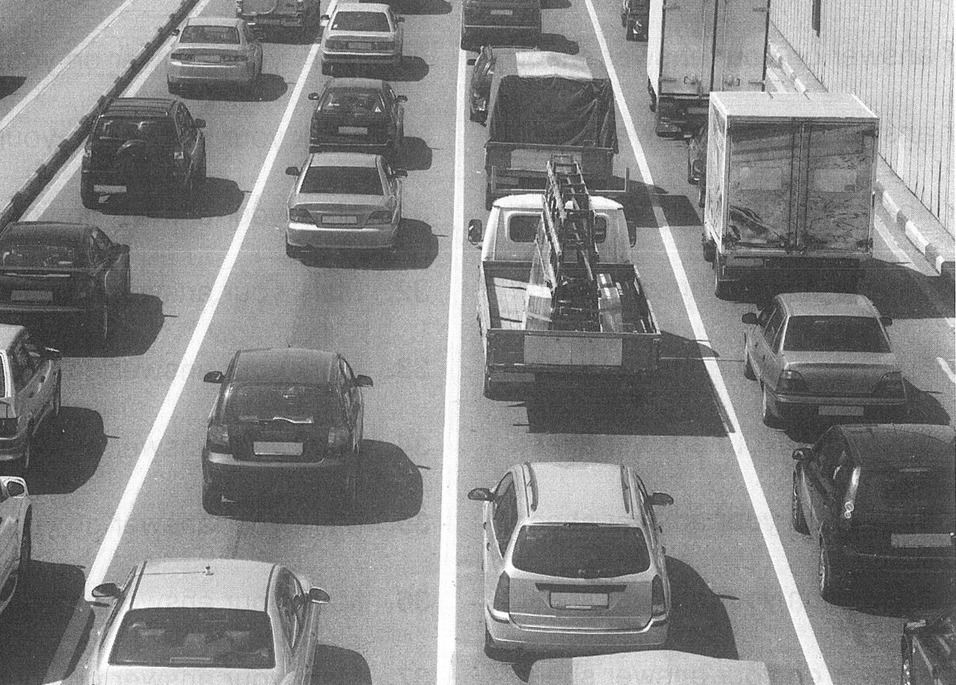

• The highway is devided into lanes. [Đường cao tốc được chia thành nhiều làn đường.]

• There are several kinds of vehicles on the road. [Có nhiều loại phương tiện trên đường.]

• Vehicles are moving in the same direction. [Các phương tiện đang di chuyển theo cùng một hướng.]

**II. NGHE & PHÂN TÍCH TRANH ĐỂ CHỌN CÂU ĐÚNG NHẤT:**

***1. Nghe & tập phát âm***

a. Tranh số 1 **(41.mp3)**

|  |  |
| --- | --- |
|  | (A) There’s a clock in the tower.  (B) There’s a towel hanging outside.  (C) There’s a person on the balcony.  (D) There’s a watch next to the window. |

b. Tranh số 2 **(42.mp3)**

|  |  |
| --- | --- |
|  | (A) Chairs have been stacked in the corner of the room.  (B) The silverware is being polished.  (C) Water is being poured into the glasses.  (D) The table has been set for a meal. |

c. Tranh số 3 **(43.mp3)**

|  |  |
| --- | --- |
|  | (A) Trees are being transported down the river.  (B) Buildings are overlooking the water.  (C) Boats are passing under the bridge.  (D) Children are playing in the fields. |

d. Tranh số 4 **(44.mp3)**

|  |  |
| --- | --- |
|  | (A) The driver is checking the engine.  (B) Some tires are being repaired.  (C) Some workers are opening boxes.  (D) The truck is parked next to containers. |

e. Tranh số 5 **(45.mp3)**

|  |  |
| --- | --- |
|  | (A) The people are eating the pies.  (B) The desserts are on display.  (C) The prices are clearly visible.  (D) The pies are being sliced. |

***2. Câu hỏi luyện tập***

**01. (46.mp3)**

|  |  |
| --- | --- |
|  | (A) The airplanes are _______.  (B) The airplanes are _______ at a high altitude.  (C) The airplanes are _______.  (D) The airplanes are _______ the ground. |

**02. (47.mp3)**

|  |  |
| --- | --- |
|  | (A) The chairs are _______ against the wall.  (B) The audience is _______ down.  (C) The chairs have been _______ in rows.  (D) The _______ has begun. |

**03. (48.mp3)**

|  |  |
| --- | --- |
|  | (A) The _______ are empty.  (B) The vegetables are _______.  (C) The goods are _______.  (D) The _______ have been opened. |

**04. (49.mp3)**

|  |  |
| --- | --- |
|  | (A) The boat is _______ people.  (B) The boat is _______ at the dock.  (C) Some boats are _______ each other on the water.  (D) There are _______ next to the river. |

**05. (50.mp3)**

|  |  |
| --- | --- |
|  | (A) The office is _______ supplies.  (B) Someone is _______ at the computer.  (C) Supplies are _______ in the warehouse.  (D) The _______ in the office are empty. |

**06. (51.mp3)**

|  |  |
| --- | --- |
|  | (A) The fountain is _______ water into the air.  (B) People are _______ in the pool.  (C) Water is _______ down the mountain.  (D) Children are _______ from the water fountain. |

**07. (52.mp3)**

|  |  |
| --- | --- |
|  | (A) The table is _______ a cloth.  (B) The chairs are _______.  (C) The carpet is _______.  (D) The sofa is _______. |

**08. (53.mp3)**

|  |  |
| --- | --- |
|  | (A) A _______ has been placed on a counter.  (B) _______ have been fastened to the ceiling.  (C) A large painting has been _______ a desk.  (D) Armchairs are _______ of a fireplace. |

**09. (54.mp3)**

|  |  |
| --- | --- |
|  | (A) Some boats are _______ to pier.  (B) Some people are _______ a dock.  (C) One of the boats is _______ from the shore.  (D) A sail has been _______ above a ship. |

**10. (55.mp3)**

|  |  |
| --- | --- |
|  | (A) There’s a _______ against the wall.  (B) There are _______ stacked on the floor.  (C) A floor lamp _______ a desk.  (D) Reading materials are _______ on a table. |

**11. (56.mp3)**

|  |  |
| --- | --- |
|  | (A) Vehicles are _______ a bridge.  (B) There’s a _______ above a street.  (C) Passengers are _______ a bus.  (D) Some cars are _______ in a garage. |

**12. (57.mp3)**

|  |  |
| --- | --- |
|  | (A) There’s a _______ on the ground.  (B) A vehicle’s _______.  (C) Earth is _______ into a truck.  (D) There’s a _______ on the wall. |

**13. (58.mp3)**

|  |  |
| --- | --- |
|  | (A) Signs are _______ on the cabinet doors.  (B) Some glasses have been _______ near the sink.  (C) A coffee machine has been _______ on the counter.  (D) The containers have been _______ water. |

**14. (59.mp3)**

|  |  |
| --- | --- |
|  | (A) A sign is _______ above some artwork.  (B) Plants are _______ on a stairway.  (C) A round table is _______ by chairs.  (D) An area rug has been _______. |

**15. (60.mp3)**

|  |  |
| --- | --- |
|  | (A) Lamposts are _______ in a row.  (B) A crowd of people has _______ on a beach.  (C) A garden has been _______ on a rooftop.  (D) The roadway is full of _______. |

**III. BÀI TẬP VỀ NHÀ**

**01. (61.mp3)**

|  |  |
| --- | --- |
|  | (A) Trees are _______ under an archway.  (B) Passengers are waiting to _______ a train.  (C) A high wall _______ the train tracks.  (D) A train is about to _______ a bridge. |

**02. (62.mp3)**

|  |  |
| --- | --- |
|  | (A) A painting is _______ on the wall.  (B) Some people are _______ a meal.  (C) The table is _______.  (D) A lamp is _______. |

**03. (63.mp3)**

|  |  |
| --- | --- |
|  | (A) The motorcycle has been _______.  (B) The motorcycle is _______.  (C) A tire has been _______ from the motorcycle.  (D) The seat of the motorcycle is _______. |

**04. (64.mp3)**

|  |  |
| --- | --- |
|  | (A) Some bags are _______.  (B) The closet has been _______.  (C) The shelves are _______ boxes.  (D) Some clothes are _______ the floor. |

**05. (65.mp3)**

|  |  |
| --- | --- |
|  | (A) The chairs are _______ against the wall.  (B) People are _______ into the water.  (C) Waiters are _______ at the gate.  (D) The tables are _______ in a row. |

**06. (66.mp3)**

|  |  |
| --- | --- |
|  | (A) Some cars are _______ along a street.  (B) Some trees are _______.  (C) Traffic is _______ by an officer.  (D) The buildings are _______. |

**07. (67.mp3)**

|  |  |
| --- | --- |
|  | (A) The books have been _______ in piles.  (B) The bookshelves have _______.  (C) The cart has been _______ its side.  (D) The files have been _______ on the bookshelf. |

**08. (68.mp3)**

|  |  |
| --- | --- |
|  | (A) The bicycles are _______ the ground.  (B) The people are _______ their cars down the road.  (C) The bicycles are _______ in front of the buildings.  (D) The people are _______ their bicycles along the street. |

**09. (69.mp3)**

|  |  |
| --- | --- |
|  | (A) The pins have been _______ into the board.  (B) The cups have been _______.  (C) The closet is _______ boxes.  (D) Pencils have been _______ in containers. |

**10. (70.mp3)**

|  |  |
| --- | --- |
|  | (A) There’s a _______ next to the beds.  (B) There are no _______ on the bed.  (C) There’s a stack of _______ on the shelf.  (D) There’s a _______ above the beds. |

**11. (71.mp3)**

|  |  |
| --- | --- |
|  | (A) The signs are _______.  (B) The building is under _______.  (C) The bicyclists are _______ the streets.  (D) Some cars are _______ on the street. |

**12. (72.mp3)**

|  |  |
| --- | --- |
|  | (A) Customers are _______ to pay for their books.  (B) The people are _______ at a table.  (C) There are boxes _______ on the table.  (D) Many books are _______. |

**13. (73.mp3)**

|  |  |
| --- | --- |
|  | (A) The traffic is _______ through the city.  (B) The vehicles are _______ the tunnel.  (C) The buses are _______ in a row.  (D) The buildings have no _______. |

**14. (74.mp3)**

|  |  |
| --- | --- |
|  | (A) The bed has not been _______ today.  (B) The curtains have been _______.  (C) There’s a _______ hanging on the wall.  (D) There’s a _______ at the foot of the bed. |

**15. (75.mp3)**

|  |  |
| --- | --- |
|  | (A) The tables in the restaurant are _______.  (B) The chairs have been _______.  (C) The restaurant is _______ diners.  (D) There’s a _______ next to the door. |

**16. (76.mp3)**

|  |  |
| --- | --- |
|  | (A) There are _______ on the wall.  (B) The tables are _______ tablecloths.  (C) The chairs are _______.  (D) The piano is _______. |

**17. (77.mp3)**

|  |  |
| --- | --- |
|  | (A) Cheese is _______ for a customer.  (B) Cheese has been _______ into cartons.  (C) Labels are _______ to pieces of cheese.  (D) Cheese has _______ into different sizes. |

**18. (78.mp3)**

|  |  |
| --- | --- |
|  | (A) The furniture is _______.  (B) The carpet has been _______ in the corner.  (C) Some pillows are _______ beside a bed.  (D) Bedding has been _______ and _______ on a mattress. |

**19. (79.mp3)**

|  |  |
| --- | --- |
|  | (A) Some chairs are _______ by the side of a swimming pool.  (B) A tugboat is _______ a ship out to sea.  (C) Umbrellas are _______ people from the rain.  (D) Leaves are _______ from the pool. |